Class activity-10.07.2026
Name: S.Padmaja
Reg no:192424159

1.Student Performance :
install.packages("ggplot2")
library(ggplot2)
student <- data.frame(
Student_ID = c(101,102,103,104,105,106,107,108,109,110,
111,112,113,114,115,116,117,118,119,120),
Attendance = c(95,88,76,90,82,98,74,91,85,79,
93,87,96,81,89,77,94,83,92,80),
Internal_Marks = c(92,85,70,89,80,96,68,90,82,75,
91,84,95,78,86,72,93,81,90,76),
Department = c("CSE","AI","IT","ECE","CSE","AI","IT","ECE",
"CSE","AI","IT","ECE","CSE","AI","IT",
"ECE","CSE","AI","IT","ECE")
)
print(student)
str(student)ggplot(student,
aes(x = Attendance,
y = Internal_Marks,
color = Department)) +
geom_point(size = 4) +
labs(
title = "Student Academic Performance Dashboard",
x = "Attendance (%)",
y = "Internal Marks",
color = "Department"
) +
theme_minimal()
Output :
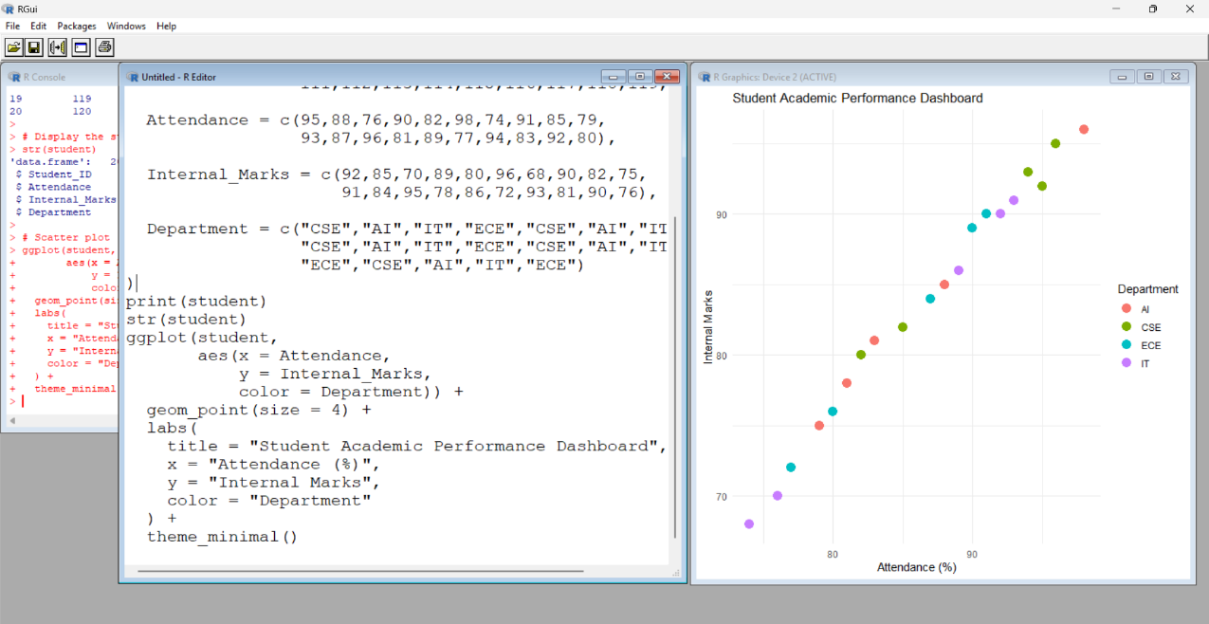

2.Electric Vehicle Market Analysis :
Code:
install.packages("ggplot2")
library(ggplot2)
ev <- data.frame(
Vehicle_Model = c("Nexon EV", "Tiago EV", "MG ZS EV", "BYD Atto 3",
"Tata Curvv EV", "Mahindra XUV400", "Hyundai Kona",
"BYD Seal", "Kia EV6", "MG Windsor EV"),

Battery_Capacity = c(30, 24, 50, 60, 55, 40, 39, 82, 77, 45),

Price = c(15, 9, 23, 34, 22, 18, 24, 45, 60, 20),
Driving_Range = c(325, 250, 461, 521, 500, 375, 452, 650, 708, 420),
Manufacturer = c("Tata", "Tata", "MG", "BYD", "Tata",
"Mahindra", "Hyundai", "BYD", "Kia", "MG")
)
print(ev)
str(ev)
ggplot(ev,
aes(x = Battery_Capacity,
y = Price,
size = Driving_Range,
color = Manufacturer)) +
geom_point(alpha = 0.7) +
labs(
title = "Electric Vehicle Market Analysis",
x = "Battery Capacity (kWh)",
y = "Price (Lakhs)",
size = "Driving Range (km)",
color = "Manufacturer"
) +
theme_minimal()
Output : 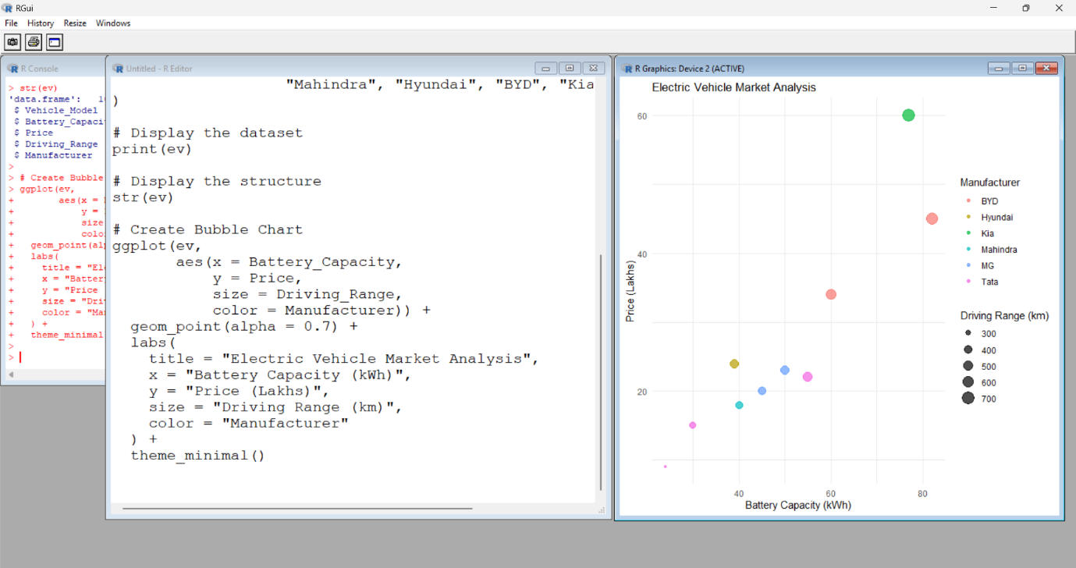

3.Hospital Patient Admission Analysis :
Code :
install.packages("ggplot2")
library(ggplot2)
hospital <- data.frame(
Department = c("Cardiology","Neurology","Orthopedics","Pediatrics","General"),
Number_of_Patients = c(120,85,95,140,180),
Average_Treatment_Cost = c(50000,65000,40000,30000,25000)
)
print(hospital)
str(hospital)
ggplot(hospital,
aes(x=Department,
y=Number_of_Patients,
fill=Department)) +
geom_bar(stat="identity") +
geom_text(aes(label=Average_Treatment_Cost),
vjust=-0.5,
size=4) +
labs(title="Hospital Patient Admission Analysis",
x="Department",
y="Number of Patients") +
theme_minimal()
Ouput : 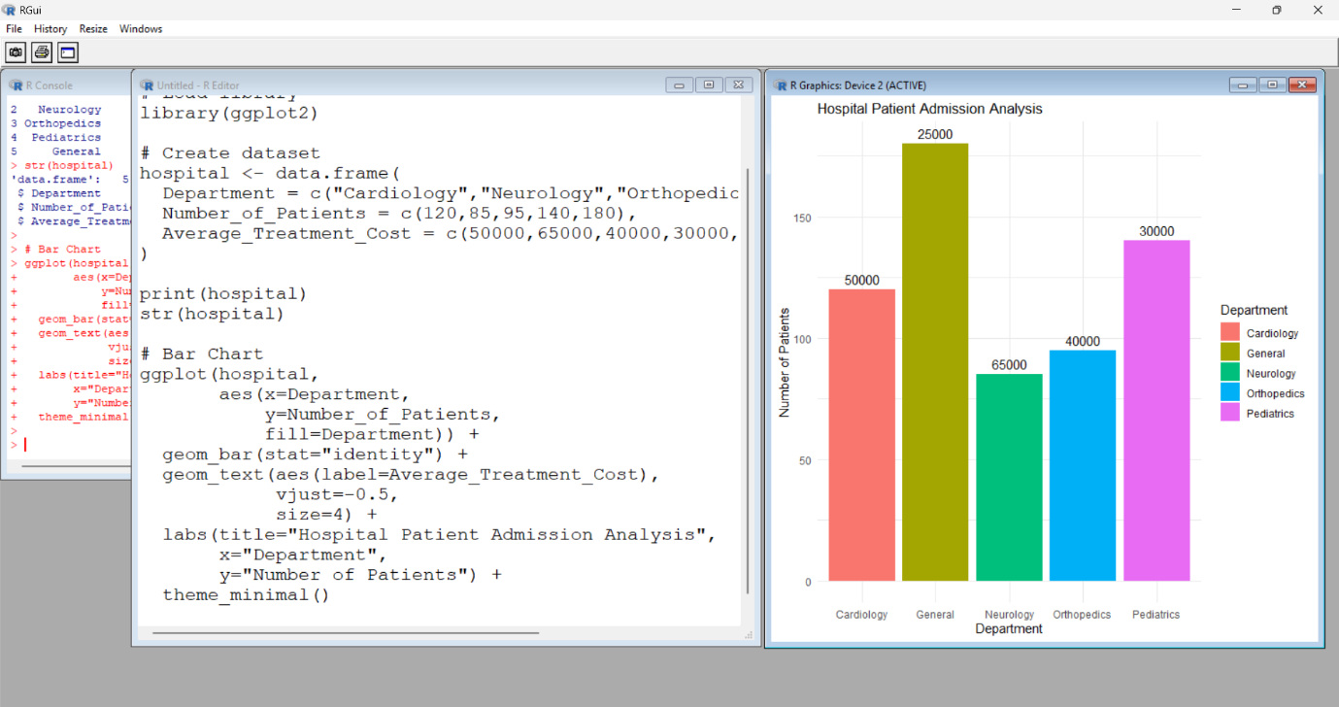

4.Weather Monitoring system
Code :
install.packages("ggplot2")
library(ggplot2)
weather <- data.frame(
Date = rep(1:10,3),
Temperature = c(
32,33,31,34,35,36,35,34,33,32,
28,29,30,31,30,29,28,27,28,29,
35,36,37,36,35,34,35,36,37,38
),
City = rep(c("Chennai","Bangalore","Delhi"),each=10)
)
print(weather)
ggplot(weather,
aes(x=Date,
y=Temperature,
color=City,
linetype=City,
group=City))+
geom_line(size=1.2)+
labs(title="Weather Monitoring System",
x="Day",
y="Temperature (°C)")+
theme_minimal()
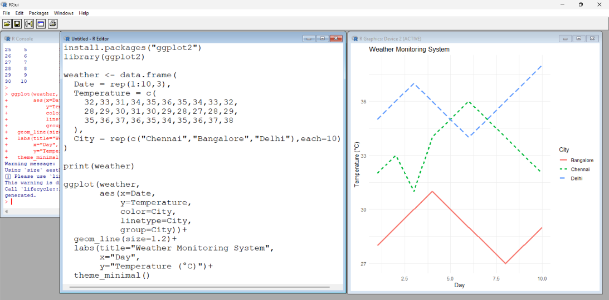
5.Supermarket Sales Analysis :
Code :
install.packages("ggplot2")
library(ggplot2)

sales <- data.frame(
Month=c("Jan","Jan","Jan","Jan","Feb","Feb","Feb","Feb"),
Product_Category=c("Grocery","Electronics","Clothing","Furniture",
"Grocery","Electronics","Clothing","Furniture"),
Sales_Amount=c(80000,60000,45000,50000,
90000,65000,48000,55000),
Branch=c("A","A","B","B","A","A","B","B")
)
print(sales)
ggplot(sales,
aes(x=Product_Category,
y=Sales_Amount,
fill=Branch))+
geom_bar(stat="identity",
position="dodge")+
facet_wrap(~Month)+
labs(title="Supermarket Sales Analysis",
x="Product Category",
y="Sales Amount")+
theme_minimal()
Output : 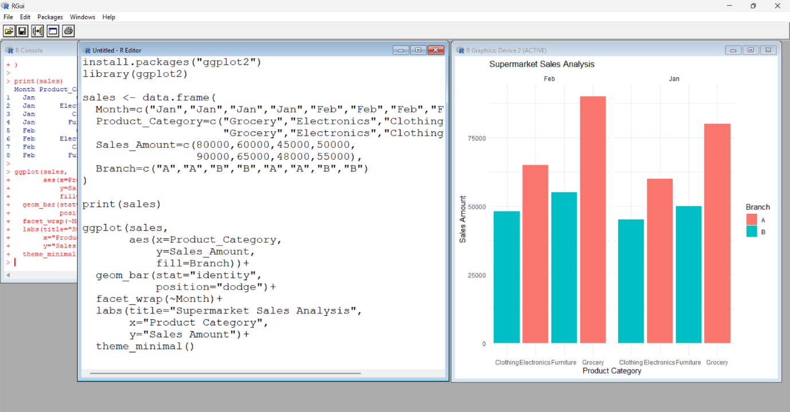
6.Employee salary distribution
Code :
install.packages("ggplot2")
library(ggplot2)
employee <- data.frame(
Employee_ID=1:20,
Salary=c(25000,30000,28000,40000,35000,45000,50000,55000,60000,
65000,70000,72000,75000,80000,85000,90000,95000,
100000,105000,110000),
Experience=c(1,2,2,3,3,4,5,5,6,6,7,8,8,9,10,11,12,13,14,15),
Department=c("HR","HR","IT","IT","Sales","Sales","Finance","Finance",
"HR","IT","Sales","Finance","HR","IT","Sales",
"Finance","HR","IT","Sales","Finance")
)
print(employee)
ggplot(employee,aes(x=Salary))+
geom_histogram(binwidth=10000,
fill="skyblue",
color="black")+
labs(title="Employee Salary Distribution",
x="Salary",
y="Frequency")+
theme_minimal()
Output :
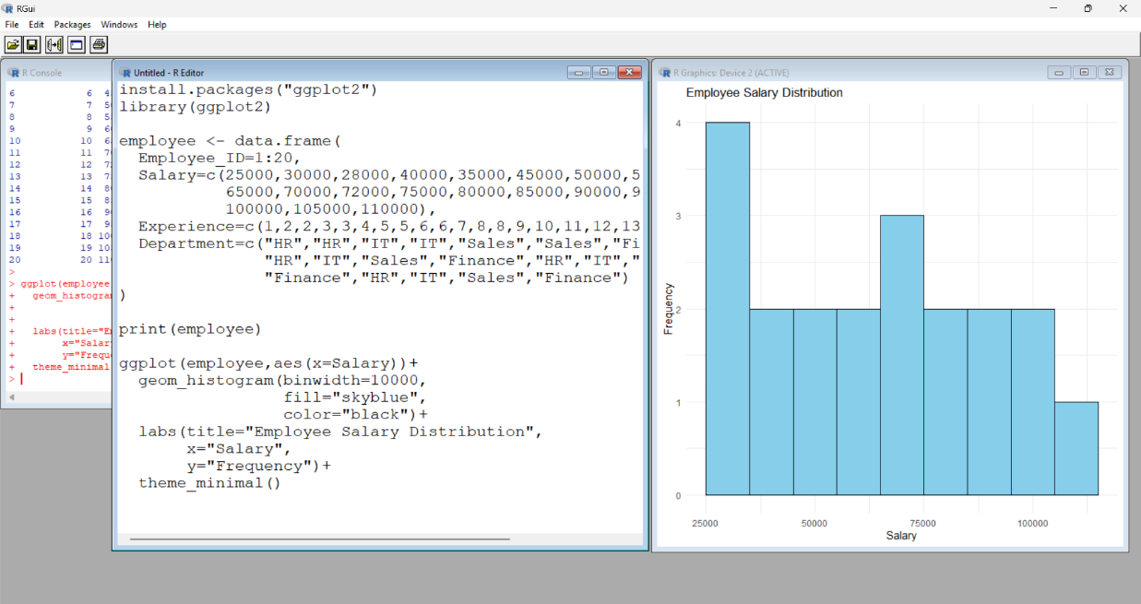
7.Smart phone analysis
Code :
install.packages("ggplot2")
library(ggplot2)

phone <- data.frame(
Brand=c("Samsung","Apple","OnePlus","Xiaomi","Vivo",
"Oppo","Realme","Motorola"),
RAM=c(8,6,12,8,8,12,6,8),
Processor_Speed=c(2.8,3.2,3.1,2.9,2.7,3.0,2.6,2.9),
Price=c(45000,85000,50000,30000,28000,42000,22000,35000),
Storage=c(128,256,256,128,128,256,64,128)
)
print(phone)
ggplot(phone,
aes(x=RAM,
y=Price,
shape=Brand,
size=Storage,
color=Processor_Speed))+
geom_point(alpha=0.8)+
labs(title="Smartphone Market Comparison",
x="RAM (GB)",
y="Price")+
theme_minimal()
Output : 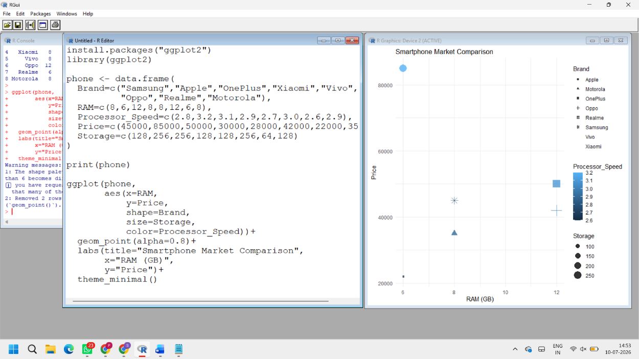
8.Online Movie Rating Analysis
Code : install.packages("ggplot2")
library(ggplot2)

movies <- data.frame(
Genre=c("Action","Comedy","Drama","Horror","Sci-Fi",
"Action","Comedy","Drama","Horror","Sci-Fi"),
Release_Year=c(2023,2023,2023,2023,2023,
2024,2024,2024,2024,2024),
Average_Rating=c(8.5,7.2,8.8,6.9,9.0,
8.7,7.5,9.1,7.0,9.3),
Number_of_Reviews=c(1500,1200,1800,900,2000,
1600,1300,1900,950,2200)
)

print(movies)

ggplot(movies,
aes(x=Release_Year,
y=Genre,
fill=Average_Rating))+
geom_tile(color="white")+
scale_fill_gradient(low="yellow",high="red")+
labs(title="Movie Rating Heatmap",
x="Release Year",
y="Genre")+ theme_minimal()
Output :
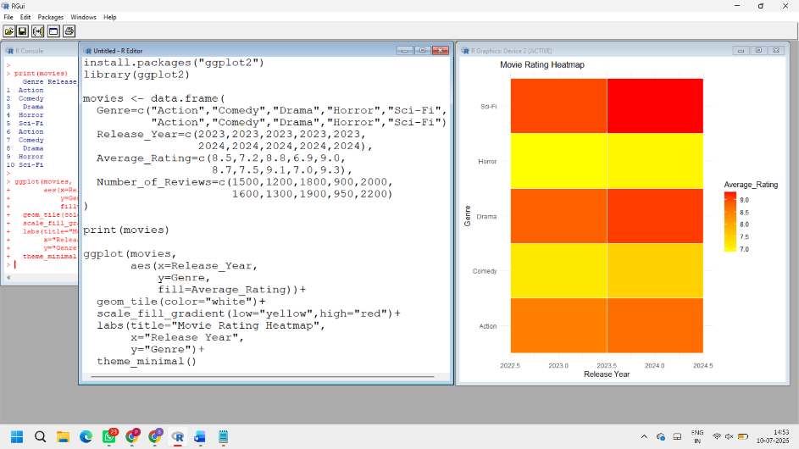
9. COVID-19 State-wise Analysis
CODE: install.packages("ggplot2")
library(ggplot2)

covid <- data.frame(
State=c("Tamil Nadu","Karnataka","Kerala","Maharashtra","Delhi"),
Active_Cases=c(5200,4300,6100,8200,3000),
Vaccination_Percentage=c(92,90,94,91,89),
Population=c(75,68,35,124,20)
)
print(covid)
ggplot(covid,
aes(x=1,
y=reorder(State,Active_Cases),
fill=Active_Cases))+
geom_tile(color="white")+
scale_fill_gradient(low="lightyellow",
high="darkred")+
labs(title="COVID-19 State-wise Analysis",
x="",
y="State")+
theme_minimal()
OUTPUT:
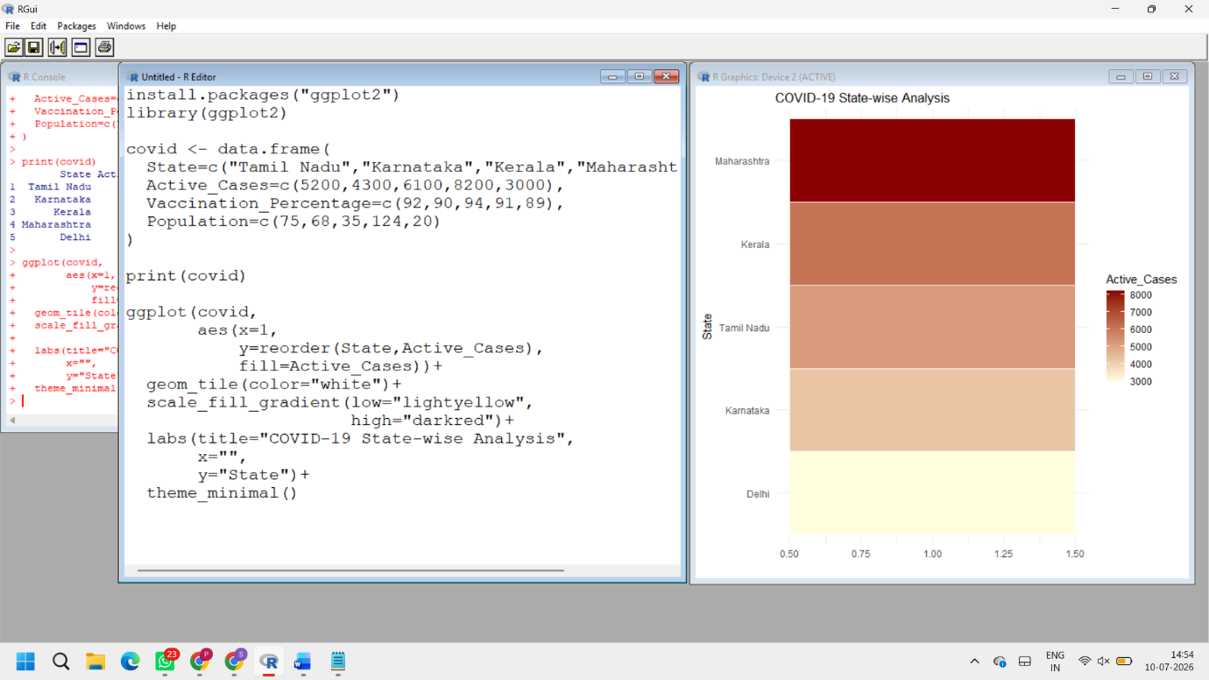

10. Iris Flower Classification
CODE : install.packages("ggplot2")
library(ggplot2)
print(head(iris))
ggplot(iris,
aes(x=Sepal.Length,
y=Petal.Length,
color=Species,
shape=Species,
size=Sepal.Width))+
geom_point(alpha=0.8)+
labs(title="Iris Flower Classification",
x="Sepal Length",
y="Petal Length")+
theme_minimal()
OUTPUT :
